

UNIVERSITY OF ALBERTA

PeopleSoft HCM

Creating Staff List and Academic Increment Pool for APO’s (PREPD)



Prepared by: HRS Process Development and Training
Updated on 4/17/2019 8:57:00 AM

Copyright © 2019 University of Alberta
All rights reserved.

The information contained in this manual is proprietary and confidential to the University of Alberta. No part of this manual may be reproduced or transmitted in any form or by any means, electronic or mechanical, including photocopying, recording, or by any information storage and retrieval system, without express written permission from the University of Alberta.

Every effort has been made to make this manual as complete and as accurate as possible. The University of Alberta shall accept neither liability nor responsibility to any person or entity with respect to any loss or damages in connection with or arising from the information contained in this manual.

The names of software products referred to in this manual are claimed as trademarks or registered trademarks of their respective companies.

Creating Staff List and Academic Increment Pool for Administrative Professional Officer’s (APO)
Each year, Faculty and Departments are required to review the performance of eligible staff members. The purpose of this report is to determine who are eligible and the number of increments (increment pool) available for distribution. The reports are prepared on the basis of information known at the time. Amendments may be necessary as additional information is made known.
In this topic, you will be provided the steps involved in the generation process of the APO Increment Pool which creates the ‘Staff List” and the timelines in which steps need to be completed.
Please note that MAPS employees are not included as they have their own process.
In determining the number of staff eligible to be considered for increments, the following rules apply:
- All eligible staff members covered by the APO agreement.
- Staff members who are at the salary cap are NOT included in the increment pool but are kept on the staff list for review.
- Staff members who joined the University from April1, 2018 to July 1, 2018 eligible for a full increment effective July 1, 2019 and are counted in the increment pool.
- Staff members who join the University on July 2, 2018 through December 31, 2018 receive a pro-rated increment effective July 1, 2019 and will be included in the increment pool.
- Staff members who join the University on January 1, 2019 – March 31, 2019 will not normally be eligible to receive an increment and not included in the increment pool calculation. Manually add these staff members to the Staff List.
- Staff members who are on full or partial disability leave are NOT included in the increment pool. The staff member should be moved from the staff list and reported on the final submission report at the bottom of the template.
- Staff members on Leave for more than 6 months of the review year are included in the increment pool but would receive an increment of 0C (On Leave).
- For those staff members on Leave for less than 6 months of the review period receive regular increments and included in the pool.
- Leaves would include Medical, Childbirth, Parental, CCEL, and Professional & Education.
- Retiring staff members are treated differently depending on the retirement date and the phased post retirement option. Read Article 18 of the APO Agreement for program details.
REMINDER:
- The review period - APO – April 1, 2018 – March 31, 2019
- Increment Effective Date – July 1, 2019

General Information
Ensure you have the most recent versions of the following documentation for quick reference:
- APO Agreement
- APO salary scales and steps
Timeline:
- After Feb 1, 2019 - Begin the process of report generation
- Final Pool Review for Faculties/Depts to be emailed to Employment Services by Feb 28, 2019 for verification

APO Agreement Timeline

Suggested Timeline | Process Step
By April 1 | Supervisor will request annual report form from APOs.
By April 15 | APO submits completed Annual Report to supervisor.
By April 30 | APO and Supervisor meet to review/ modify and complete final copy of Annual Report.
By May 15 | Dean/ Vice-President reviews supervisor’s summary and increment recommendation.
By May 22 | Completed Reports to Employment Services for review
By June 1 | Dean or Vice-President submits increment recommendations to Provost or delegate for review and approval.
By July 31 | Provost or delegate informs APO of final increment decision.

Step 1: Run Academic Increment Report – Current Evaluation Year
Navigation Path: Main Menu > Workforce Administration > Salaries* > Report > Acad Incr/Prom Rpt* > Select your Run Control ID INCR_RPT or Add a New ID
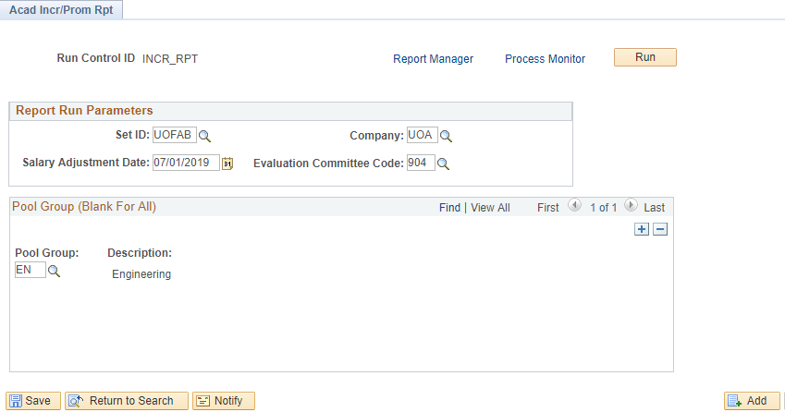
- Salary Adjustment Date is the date the increment recommendations from the FEC will be effective.
- Ensure you select the Evaluation Committee Code from the drop down menu for the group you want to run the report for. Select Evaluation Committee Code 904.
- In the Pool Group field select the Faculty you have access to.
- Click SAVE.
- Click RUN.
- On the Process Scheduler Request ensure the report returns in an XLS format.
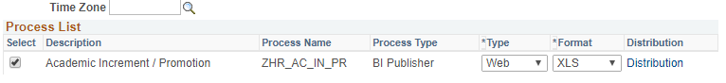

- Click OK.
- Click on Process Monitor link.
- When the report runs to completion, you should see a Run Status of Success and a Distributed Status of Posted. The report is ready for viewing.
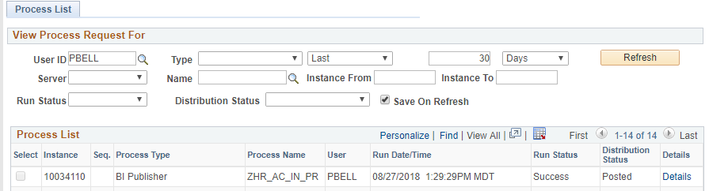
10. Click on Go back to Acad Incr/Prom Rpt* link at the bottom of the Process List 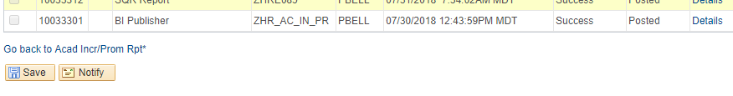
11. Click on Report Manager or Navigate as stated in Step 2.
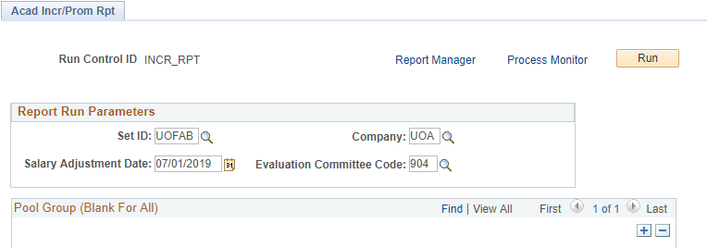
Step 2: Create Pivot Table (If Needed)
 | Navigation Path: Main Menu > Reporting Tools > Report Manager
 | Click the ZHR_INCR_PRO – Academic Increment Promotion.xlsx report.
Before creating the final report template, perform several data sorts to remove those that are not considered eligible for an increment
Create Pivot Table – Headcount
- First Tab is Base Data and should not be changed. Highlight and copy the entire spreadsheet and SAVE to a new tab
- Delete the top 9 rows of the spreadsheet on Tab 2.
- Rename Tab 2 to Staff List Final
- Highlight all rows and click Insert
- Click Pivot Table then click OK. This will create a new Tab.
- Highlight Empl ID and drag to VALUES box
- Highlight Step on Scale and drag to ROWS box
- Rename Tab to Headcount Summary

 | 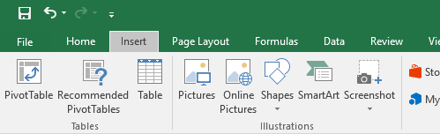
TIP
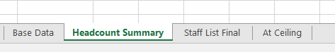
Create separate tabs:
- Base Data – Initial Increment Report - Use to balance back to – Do Not change this data
- Headcount Summary is created by the Pivot table from the Staff List Final
- Staff List Final – Use this list for the copy and paste to the Employment Services Template
- At Ceiling is the list of APO’s at Ceiling
- All groups will remain on the Staff List but will not all be included in the calculation of the increment pool

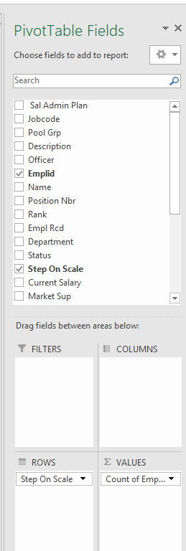
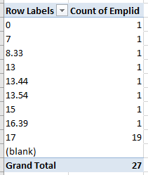

The Grand Total is the maximum headcount for the APO increment pool

Step 3: Data Cleanse – APO at Ceiling
1. | APO at Ceiling  - Review the salary scales for the APO by Step on Scale.  - Click Staff List Final tab of the excel spreadsheet  - Click the Filter option on  - Click the Filter, uncheck Select All box and Select only 17.00  - Copy all employees at Ceiling to the At Ceiling Tab  All APOs at ceiling are NOT eligible for an increment.  - These staff members remain on the Staff List for review but a 1.1 increment will NOT be attributed in the pool
Step 5: Data Cleanse – Leave & Disability Leave
Identify all staff members who were on Leave
- Data cleanse - Staff members on Leave - flag those that have 0 C (On Leave)
- Leaves would include Medical, Childbirth, Parental, CCEL and Professional & Education
Identify all staff members who are on Partial or Full Disability Leave/Medical Leave
- Data cleanse - Staff members on full or partial disability leave - Not included in the increment pool after first year of disability - Move to Disability section of template
- To ensure the employee has been on leave during the review period, navigate to Workforce Administration and note leave dates. If a ‘one at a time’ solution is not an option, then you may request a report of all APOs on leave from Employment Services

Step 6: New Hires April 1st to July 1st
New Hires April 1st to July 1st

- Manually add any new starts, not captured when the report was generated, for the above dates in the Staff List and include in the Increment Pool

New Hires July 2nd to December 31st

- New starts within these dates will receive a pro-rated increment and will be included in the increment pool.

New Hires January 1st – March 31st

- Not normally eligible for an increment and not included in the pool calculation. Manually add to the Staff List.
Step 7: Retirements and Resignations
1. | Retirements  - If a retirement is received after the report is generated, the Staff List and Increment Pool should be amended accordingly
2. | Resignations  - All resignations will be removed from the Staff List and NOT included in the calculation of the Increment Pool
Step 8: Review Checklist
Retirements | Adjusted base on terms of retirement agreement
Resignations | Adjust increment pool for all confirmed resignations
New Hires | Confirm all new hires between April 1st to July 1st are included on the Staff List and the Increment Pool calculation. Manually add to the Staff List if unknown at the time of report generation.
APO at ceiling | Review data for APOs at ceiling. Do NOT include in the Increment Pool calculation.
Staff Members on Leave | Adjust Staff List for those on Leave 0 C (on Leave)
Staff Members on Disability/Med Leave | Adjust Staff List for those on partial or full disability
Secondment | Identify any staff member on Secondment and refer to the Secondment Agreement for assessment directive

Step 9: Submit Increment Pool Calculation to Employment Services for Review
1. |  | Submit Increment Pool Calculation to Employment Services
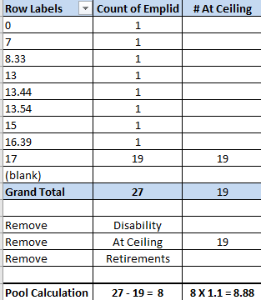

*Note: There may be staff members over Step 17.

2. |  | Submission to Employment Services should include the following:  - Working Spreadsheet - 4 Tabs  - Completed APO Increment Report Template
Step 10: Prepare Staff List Increment Pool for Senior Administrator
1.  2.  3.  4. | Prepare Increment Pool Staff List  Once all the data has been reviewed and sorted:  - Highlight all rows starting at Empl ID column F  - Copy and paste into the template from Employment Services  - Update Header of template with your Faculty/Department name.  - Ensure the template format is continued to the bottom of your staff list.  - Prepare email summary and attach the spreadsheet for Employment Services review.  End of Procedure.

